The stretch refers to the practice of exercises smooth and maintained to prepare the muscles for greater effort and to increase range of motion in the joints . It is the elongation of the muscle beyond the length it has in its resting position. We need a mat and elastic band for every person.
First of all, we will do neck stretching.
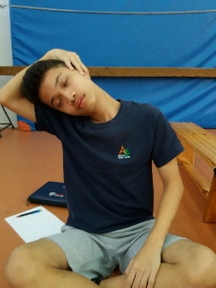 30s Neck lateral strecth: one side then the other side.
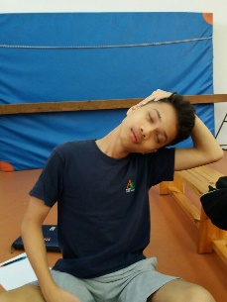 30s
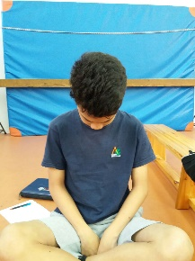 30s Neck flexion stretch: forward then back.

Second, we will do stretching of the arms and pectoral.
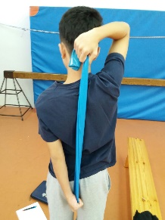 30S Shoulder routetor strecht: with elestic band, pull up with . the top arm then down with the other.
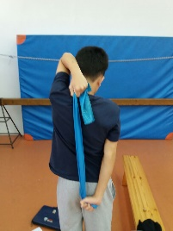30s

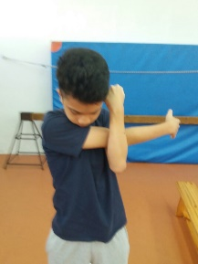 30s Side stretch for arms: put the arm to the side and straight of .
your chest and stretch out with the other hand.
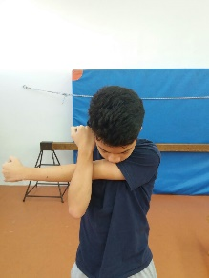 30s

30s pectoral setretch: use a bar.
30s

30s tricep strech: pull elbow across and down
30s

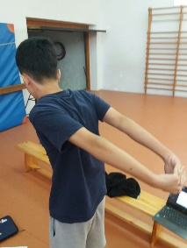 30s bicep stretch: put your arms back, take your hands and stretch up.

Third, stretch the back.
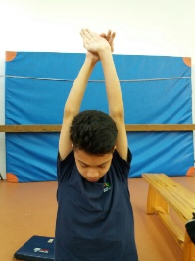 30s backsides strech: raise your arms up, grasp your hands and pull up.

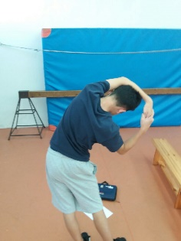 30S Lateral flexion stretch: one side then the other, push the . . pelvis across as your band.
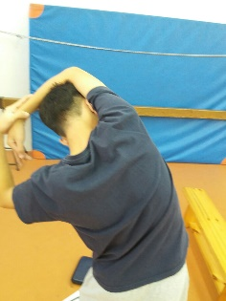 30S

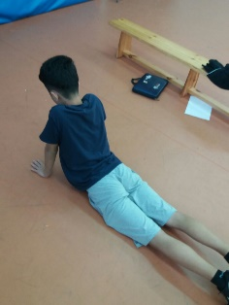 30s Lumbar stretch: Stretch on your stomach and just lift your back up.
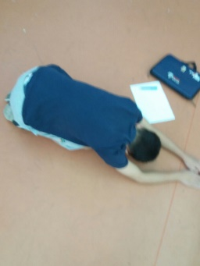 30s back stretch: reach forward with arms, push chest towards floor, each back down backside backside behind knoos.

And now, we finish stretch the legs.

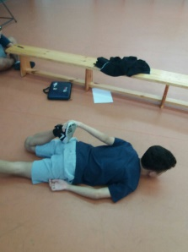30s quadriceps stretch: kneep pelvis on floor and stretch the . legs
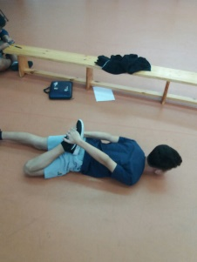30s

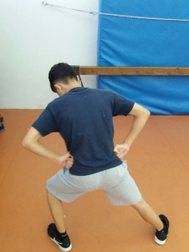 30s Adductor stretch: put one leg out and stretch the inner . . muscle.

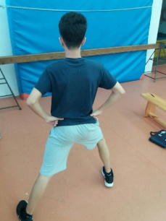 30s

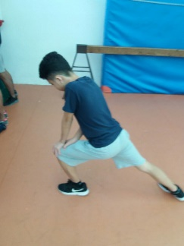30s lunges: one leg is positioned forward with knee bent and . foot flat on the ground while the other leg is positioned . . behind.
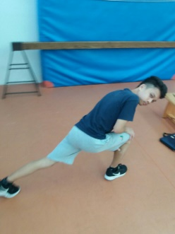30s

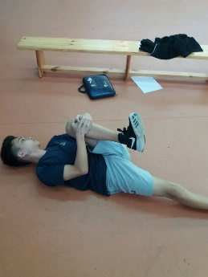 30s gluteal stretch: pull knee and lower leg towards . opposite shoulder.
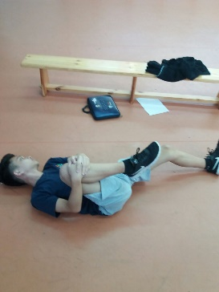 30s

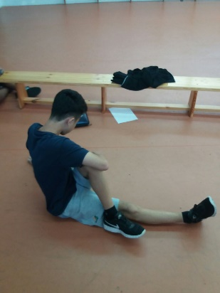 30s gluteal stretch and lumbar rotation stretch
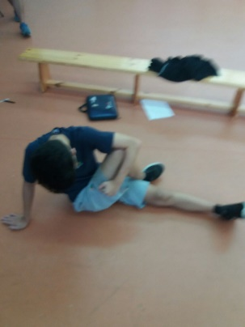 30s
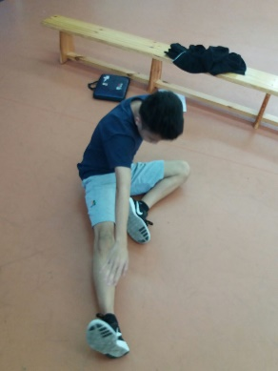 30s knee stretch: commence with the knee slightly bent, . . then push knee straight as tension allows, push chest . towards foot.
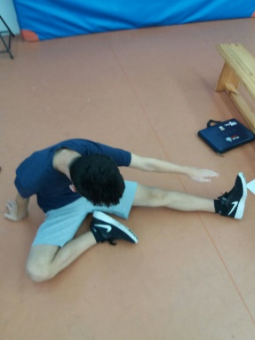30s
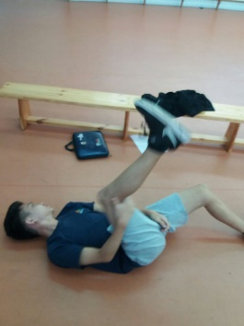 30S back quàdriceps stretch: with the foot pulled back . . towards the knee
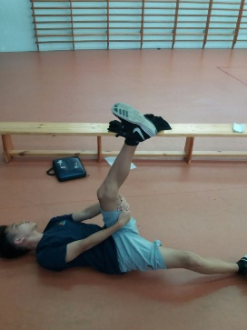30S
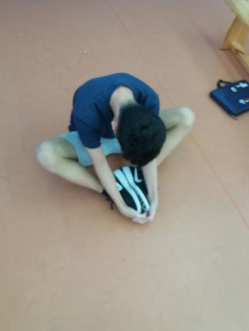 30s Touch foot leg: push down, with elbows on knees, keep back staight
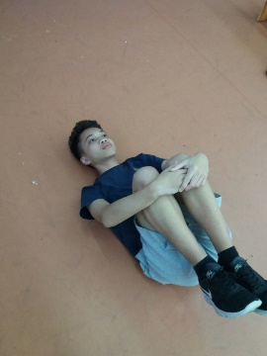 30s lumbar flexion stecth: pull knees and lower legs towards opposite shoulder.

